**Contents**

**DTH** 1

Products and Services 2

Infrastructure 2

**Head end Sub-system 4**

Introduction 4

Network Elements 4

Need and Type of Capex 6

**CAS and Middleware** 10

Introduction 10

Network Elements 11

Need and Type of Capex 13

**RF Subsystem 16**

Introduction 16

Network Elements 16

Need and Type of Capex 17

**The Monitoring and testing systems 18**

Introduction 18

Need and Type of Capex 19

## **DTH**

Direct to home (DTH) technology refers to the satellite television broadcasting process which is actually intended for home reception. It is aimed at competing with cable TV distribution services by providing higher quality satellite signals with more number of channels.

The DTH network includes a variety has infrastructure spread across the country, along with transponders placed in the satellites.

* A state-of-art broadcast facility situated at Manesar with the RF-Headend
* The Diversity site at Bangalore with the DR-Headend
* Transponders on 2 ISRO satellites: INSAT 4 CR and SES-7.

Airtel DTH currently has a customer base of 5 million subscribers since launching its operations in October 2008.

Entire DTH Setup with map and all stations-facilities

No. of areas covered by services, and setup/equipment at each place

Current and Future expansions

## **Products and Services –**

### **Digital TV** uses the latest mpeg-4 DVB S-2 sound and picture format for superior quality.

### **High definition TV and Recording** allows viewing in HD with 7.1 surround sound and recording in HD and 3D.

* Numerous **VOD (Video on Demand) and PPV (Pay-per-view)** services
* Applications and software like the **EPG (Electronic Program Guide)** and **Active Services** are provided to enhance user experience.

Is this the correct categorization?

Include any other service

## **Infrastructure –**

The headend facility can be broken down into 4 main components and sub-components

* **Head end Sub-component:**

The head end or the front end system is the heart of the network and the source of all signals. The system consists of video and audio compression encoders, multiplexers and other components to start the processing of incoming signals.

This can be further broken into 2 major processes:

Compression: Content Acquisition:

Receiving Antennae Mpeg-4 Encoder

IRD (Integrated Receiver Decoder) Multiplexer

Video Route Modulator

* **Applications and Middleware:**

The middleware is installed in the system to integrate the essential software for the working of DTH services. A number of applications and software must also be loaded that enable the customer to use the services through the STB (Set Top Box).

* User Management System -Billing
* CAS (Conditional Access System)
* Software and Applications
* NVOD (Near Video on Demand)
* **RF sub-system:**

The RF subsystem contains the uplink facility that transmits the signals to the transponders in the satellite, which in turn relay the signals back to the subscribers’ dishes. The devices here perform the last stage of processing of the signals in the system before they are finally sent for up linking.

* Group Delay Equalizer
* UP Converter
* LNA (Low Noise Amplifier)
* Uplink Antennae
* **Network Monitoring System:**

Monitoring is required to analyze the working of the system & all its components to optimize its performance. Testing is also an important process to improve the reliability of services and rectifying the errors.

* Monitoring Equipment
* DTH Test Lab

Network map covering Airtel DTH operations

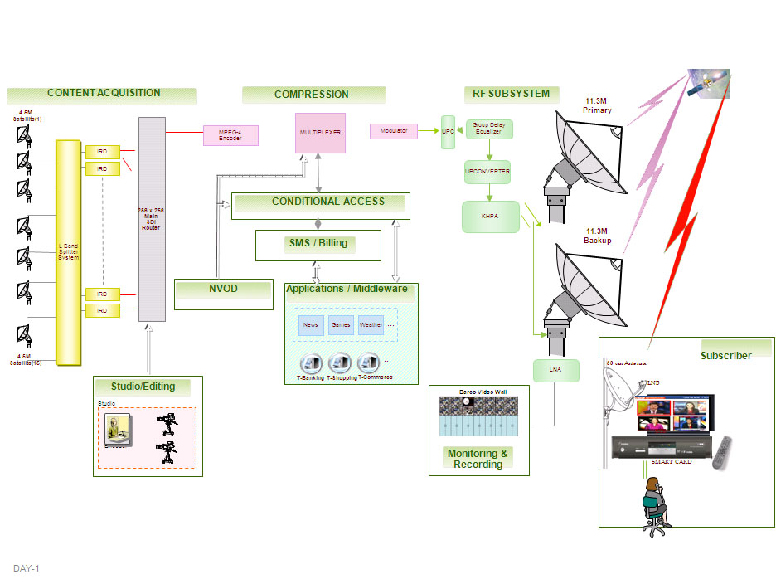

# **Head end Sub-system**

## **Introduction -**

The head end or the front end system is the heart of the network and the source of all signals. A considerable amount of funds are invested in the Headend and the network owner needs to keep in mind both, his existing needs as well as project and consider his future requirements.

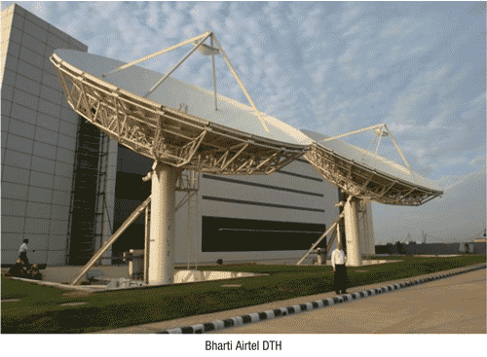

Front-end system consists of video and audio compression encoders, multiplexers and other components. The main task is to front-end system for digital TV signal coding, the use of statistical multiplexing technology in a limited frequency band to transmit more programs. The MPEG-2 compressed video and audio signals received from the broadcasters are converted to MPEG-4 which are further processed and integrated with the software and then sent to the RF sub-station for unlinking.

## **Network Elements -**

The headend facility comprises of two main systems –

* Content acquisition system
* Compression system

**Content acquisition system -**

The content acquisition system is the where the data signals are received from the broadcaster and passed on for processing.

Receiving antennae:

The receiving antennae at the headend facility acquire the data transmitted by the broadcaster in the L band frequency.

The Airtel DTH uplink facility at Manesar has a number of 4.5m dishes for receiving signals. The size of the receiving antennae varies as per the frequency band of transmission.

A Simulsat Antenna was installed at the DR-facility at Bangalore to receive signals from various Broadcaster through single antenna.

IRD :

An integrated receiver/[decoder](http://decoder) (IRD) is an electronic [device](http://circuit) used to pick-up a radio-frequency signal and convert [digital](http://digital) information transmitted in it. The IRD is used for the reception of contribution feeds that are intended for re-broadcasting, and forms the interface between a receiving [satellite dish](http://dish) and the uplink infrastructure.

Routers :

Video Routers are used for transporting video signals from inputs to outputs. The number of inputs and outputs varies dramatically. The way routers are described is normally number of inputs by number ofoutputs e.g. 2x1, 256x256. Because any of the inputs can be routed to any output, the internal arrangement of the router is arranged as a number of crosspoints which can be activated to pass the corresponding signal to the desired output.

Video Router

Receiving Antennae

IRD and L band Splitter

**Compression System -**

The Compression system takes the signals from the content acquisition system and begins processing through various stages with the addition of the middleware and applications.

MPEG-4 encoder:

The data sent by the broadcaster is encoded in MPEG-2 format and is converted into the more efficient MPEG-4 format. For optimized use of broadcast channel it is necessary to reduce the amount of data that is necessary to transport specific information which is allowed through higher compression.

DTH applications do not normally worry about encoder/decoder latency, which is critically important for encoder performance. MPEG-4 is also being used by various DTH providers to offer new HD services to customers.

Multiplexer:

The multiplexer in the DTH system plays the role of mixing all the incoming channels (not to be confused with TV channels) into a single signal at a particular frequency. Here, all the processing of the signal begins, with integration of all the software and applications that come as part of the DTH services.

Modulator:

Modulators essentially take an input signal and attach it to a specific frequency.Modulation is essential for transmission of two or more signals simultaneously. Modulation avoids any interference between the two signals and also ensures that signal errors are avoided during transmission. It entails the transformation of data using error correction and signal mapping to produce a digital carrier suitable for satellite transmission.

Modulator

Multiplexer

MPEG-4 Encoder

**Need and Type of Capex -**

Information (investment, technical specs, number of pieces, why & where they are installed in the entire network on all the equipment mentioned above i.e. IRD, multiplexer, antennae, modulator etc.

The headend is a master facility for receiving signals from the broadcaster for processing and distribution over the DTH system. As a vital element in the functioning of the DTH system, capital expenditure is made to upgrade the headend as per business requirements.

* **Technical Equipment –**

Capex is required for equipment & instruments to optimize the working of the system.

Installation of new equipment increased heat dissipation in the CAS room. With the current 3.8 TR precision AC proving insufficient, a new 6.5 TR PAC (precision air conditioner) was required to maintain the recommended temperature.

Initial Investment includes -

**Cost of new component:**

Precision Air Condition (25 Kw) with HSC, FSC, NIC card

**Additional equipment and Accessories:**

Refrigerant etc.

**Peripherals and cabling:**

Copper piping electrical cabling and copper pipe insulation

**Installation and commissioning charges**

**Project Management Fee**

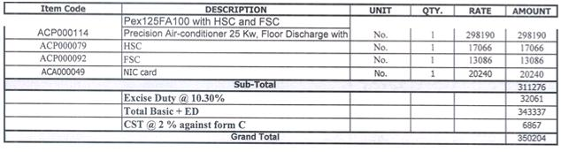

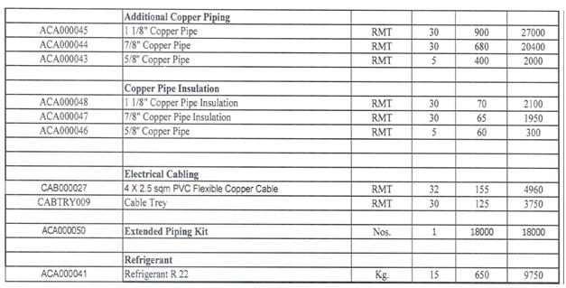

* **Addition of new functionalities in the system -**

Addition, Up-gradation and testing of new functionalities in the system is an ongoing process to improve services.

The NDS test System for videoguard headend of DTH was implemented to enable testing of upgrades and new functionalities before putting on live system.

Costs Involved -

**Cost of new equipment:**

VG Cluster (security server base infra and boards)

VG Module (Webservers, ASI isStreamer)

**Add on products and other accessories:**

OIG (Optional Catoris), Synamedi8 XTV Encryptor, Synamedia XTVS (CAB/PAS), iSSH Boards (with 24 chips)

**Installation of software:**

VGH Management Client PC, Antivirus Enterprise Windows Clients

**Racking and peripherals:**

BackuPDiSkS, 1 Blade Base Entry Crate

**Project Management Fee**

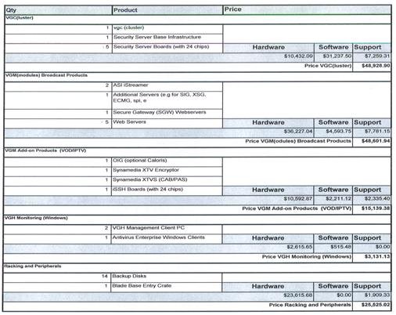

* **New Revenue Opportunity –**

Investment is required to undertake new projects and development to explore newer avenues to generate revenue and make the services that are attractive, robust and more than meet the expectation of end Customer.

Audience Measurement System (AMS) is an end-to-end system that enables DTH operator to measure subscriber-viewing behavior. AMS provides events information related to the whole TV viewing experience, including live viewing; recording, local playback, interactive applications messages, and reports the log events in a non-intrusive mode. The DTH headend was upgraded to support the Audience Measurement System (AMS), which is a functional set of EPG phase 3.0. AMS integration was undertaken by NDS, Airtel’s technology partner for EPG and CAS system

The cost involved in such an investment goes as follows –

**Cost of new components and hardware:**

iChannel (New Component)

AMS Proxy (New Component)

VG Console (Existing Component, Only upgrade)

EMMG (Existing Component, Only upgrade)

**Cost of Installation of hardware and software:**

Installation of new head end machines for AMS including: hardware, software and configuration

Modification of existing NOS Videoguard head end component configuration to support AMS and GSM functions

**Cost of Integration with the system:**

Integration with GSM Return Path Network

Integration with 3rd· party recipients of AMS Data

**Project Management Fee**

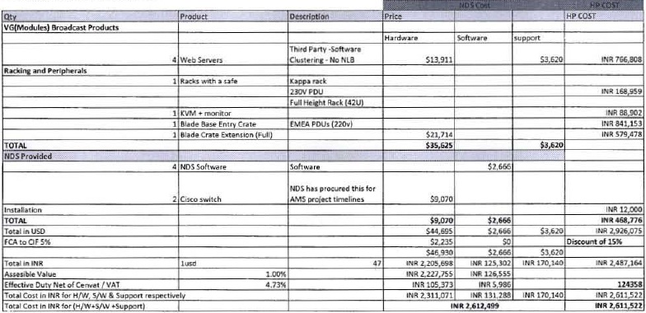

* **Investment to support growth -**

A large scale capital expenditure may be required to enable the company to expand and bring about extensive changes in the system.

Upgradation of headend Satellite migration:

Migration to a new satellite SES-7 from INSAT 4CR was undertaken to meet business requirement. This was accompanied by Technical Infrastructure & Headend system upgradation at Manesar for SES 7.

**Note:** Large scale projects undertaken by the company such as Satellite Migration involve heavy Capital Expenditure and Operational Expenditure covering a major part of the system and spanning over a number of years. Hence, its effect can be seen throughout the system.

The following table shows the cost of activities during migration to 2nd Satellite.

|  |  |
| --- | --- |
| Activity | Cost in Mn |
| CAS integration (Bangalore) | 33.50 |
| IT and Connectivity infrastructure (Bangalore) | 1.30 |
| NMS and Monitoring Services (Bangalore) | 17.83 |
| Headend Up gradation (Manesar) | 55.74 |
| RF sub system upgrade (Bangalore) | 56.81 |

## **CAS and Middleware**

## **Introduction –**

The CAS & middleware are installed in the system to integrate the essential software for the working of DTH services. During the processing of the signals, the services must be secured so that they are not vulnerable to illegal use. A number of applications and software must also be loaded that enable the customer to use the services through the STB (Set Top Box).

After the video is compressed and encoded, the data is encrypted it in order to keep people from accessing it for free. Encryption scrambles the digital data in such a way that it can be decrypted back to usable data, only if the receiver has the correct decoding satellite receiver with decryption algorithm and security keys.

The entire process can be broken down into the following –

Near Video on Demand (NVOD)

User Management System – Billing

Middleware – Applications

Conditional Access System (CAS)

## **Network Elements –**

All the devices that are used in installing the software i.e. servers/monitors etc

What does Airtel have and where

Conditional Access (CAS)

NVOD

User Management -Billing

Applications

**User Management System:**

The DTH user management system is the heart of the system, mainly to complete the following functions:

* Registration and management of user information.
* Buy and packaging programs.
* The standards for the development program in mind and users fees.
* Market Forecast and marketing.

User management System mainly consists of user information & the program information database management system and is equipped to answer the user’s queries and provide a variety of customer service Call Center composition.

**Billing Mechanism:**

The billing mechanism is programmed to lock all the program data and subsequently, allows users to view only those channels that they have subscribed for. The User management system must be secure to ensure that none of the services are being accessed illegally. For example, the programming algorithm in the Set top box is changed every 15 minutes to create an almost foolproof protection system.

**Conditional access system (CAS):**

Conditional access system has two main functions:

* Encryption of program data.
* User authorization.

The conditional access system (CAS) allows wide range of business models and provides flexibility to packages and marketing content.

Airtel DTH uses a conditional access system called ‘Videoguard’ manufactured by NDS.

**Software and Applications:**

There are various applications and programs available -

* The Electronic Program Guide (EPG) is an on-screen guide to scheduled broadcast television programs, allowing a viewer to navigate, select, and discover content by time, title, channel, genre, etc, by use of their remote control.
* Teletext (or "broadcast Teletext") offers a range of text-based information, typically including national, international and sporting news, weather and TV schedules.
* Multilingual audio tracks and Subtitles in several languages are provided in selected channels for the user’s convenience.
* ‘Active services’ to enhance user experience and interactive services to provide learning tools like puzzles and games for children.

**Development and introduction of new software:**

Airtel DTH has a number of services as part of its product development projects -

Mosaic –

Mosaic Interactive application has multiple channels in one application thus saving bandwidth to accommodate more channels. The application provides the user with the option to watch 4 different channels in a very intuitive way.

USB Media for EPG features –

This program aimed at arranging for quantities of certified USB-based Flash Drives & Hard Disks for implementing PVRLite & PDL-Lite features in the upcoming EPG Phase 3.5 for Airtel DTH platform.

Playout- DTH iMusic –

Program was launched to integrate Audio channels with EPG or interactive music application.

A 16 Channel analog stereo audio output from audio play-out Broadcast system would be integrated with the existing audio compression system of DTH.

**Video on Demand services available:**

Video on demand (VOD) systems allow users to select and watch video and clip content over a network as part of an interactive television system. Download and streaming video on demand systems provide the user with a large subset of VCR functionality including pause, fast forward, fast rewind, slow forward, slow rewind, jump to previous/future frame etc.

Near video on demand (NVOD)is a pay-per-view consumer video technique used by multi-channel broadcasters using high-bandwidth distribution mechanisms such as satellite and cable television. Multiple copies of a program are broadcast at short time intervals (typically 10–20 minutes) providing convenience for viewers, who can watch the program without needing to tune in at a scheduled point in time. This form is bandwidth intensive and is generally provided only by large operators with a great deal of redundant capacity.

Push video on demand (Push VOD)is a technique used by a number of the broadcaster on systems that lack the interactivity to provide true video on demand, to simulate a true video on demand system. The system features a Personal Video Recorder that automatically records a selection of programming, often transmitted in spare capacity over-night, for the user. The user can then watch the downloaded programming at a time of their choice.

Pay-per-view (PPV) is the system in which television viewers can purchase events to be seen on TV and pay for the private telecast of that event to their homes. The event is shown at the same time to everyone ordering it, as opposed to video on demand systems, which allow viewers to see the event at any time. Events can be purchased using an on-screen guide, an automated telephone system, or through a live customer service representative

## **Need and Type of Capex -**

Information (investment, technical specs, number of pieces, why & where they are installed in the entire network on all the equipment mentioned above i.e. servers, software etc.

Conditional Access System (CAS) is used by all the DTH operators for secure broadcast of DTH services. The growing demands of media sector to have one stop shop for all services, make it is necessary to upgrade and expand our CAS services.

* **To implement new CAS services:**

New CAS services can be introduced to gain higher market share and create a USP in the segment.

Bharti Airtel Limited had a teleport facility in Noida with infrastructure only capable of supporting FTA channels. With growing demand, A CAS was required at the teleport end to support encrypted channel service as well. A 10 channel Conditional Access System was thus set up to address the needs of the media and entertainment industry, making the company the first to offer such a service.

Cost involved –

**Cost of hardware and equipment:**

Key server, DVB server, CAS server Hardware, Cisco Switches etc.

**Accessories and peripherals for new services:**

Racks, Cabling, Switches, Client PC’s etc.

**Installation and commissioning charges**

**License fee**

**Training charges**

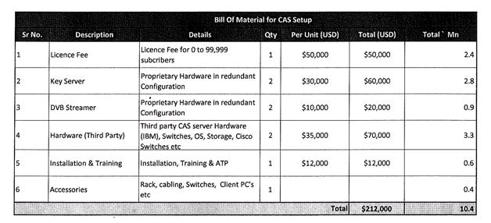

* **To upgrade existing services:**

An upgrade may be needed in the present infrastructure to support a larger customer base, as well as to improve services to enhance user experience.

A DTH CAS Headend up gradation was undertaken to support upto 10 Mn subscribers as existing infrastructure could not expand beyond 5 Mn. The DVB-SI used by STB’s was upgraded to the Bandwidth saving MH.SI information system to allow additional channels or enrich existing EPG data.

The cost of upgrade includes –

**Cost of Hardware and software for upgrade:**

Channel Support Servers, Data Carousels, VG Cluster, Anti-Virus, Firewall

**Configuration and integration of instruments & services**

**Commissioning and Testing charges**

**Project management and training charges**

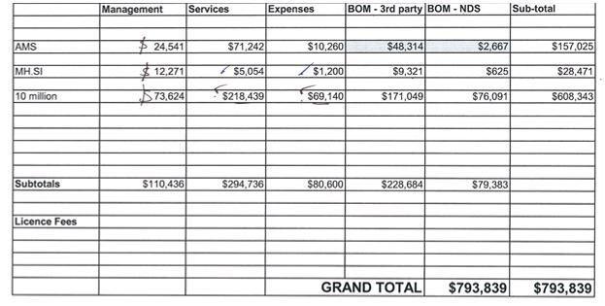

* **New projects and Initiatives:**

New projects and development need to be undertaken to be at par with the competition. Rapid advancements in technology are taking place in this field and it necessary to deliver the best and most attractive services to the customers.

The mosaic application was developed by Airtel DTH in response to a similar application in Tata Sky and VideoconD2H. It aimed at giving customers access to new content which is not there on any other network, by offering multiple channels in one application thus saving bandwidth to accommodate more channels. Hence, it would get more subscribers which in turn would bring more Carriage and Subscriber Revenue.

Cost involved –

**Cost of Hardware:**

11 lakh per Mosaic generator and no additional encoders as each mosaic saves 1 encoder

**Application Development Cost:**

Development and deployment of iDD and iDivine Mosaic application of Bharti Airtel DTH services

**Project Management Fee**

# **RF Subsystem –**

## **Introduction –**

The RF subsystem contains the uplink facility that transmits the signals to the transponders in the satellite, which in turn relay the signals back to the subscribers’ dishes. The signals after passing through the encoder and multiplexer undergoing compression are sent to the modulator. The modulator provides a carrier signal and the modulated signal enters the sub-system for further processing.

The signals entering the sub-system are all at different phases and which may cause interference & may cancel each other out. Hence, the GDE (Group Delay Equalizer) brings all the signals to one common phase. These signals are then sent through the UP converter, which converts the current L band frequency signals to the Ku Band. This step is essential as signals at higher frequencies are efficiently transmitted over long distances to widely distributed centers (subscriber’s receiving dish). The system is also closely monitored by the NMS (Network Monitoring System) which checks for any losses in the quality of video or audio.

Finally, the signals are sent over to the uplink station, which contain LNA (Low Noise Amplifiers) which amplify the signals before transmission, to travel such great distances and still have adequate strength.

The facility houses giant antennae pointed directly at the satellite so that transmission to the transponders can take place at maximum signal strength.

## **Network Elements –**

Group Delay Equalizer & UPC

Up linking

Antennae

LNA

UP Converter

Group delay equalizer –

This instrument processes the [signal](http://processing) and performs delay equalization by adjusting the relative phases of different frequencies to achieve a constant [group delay](http://delay).

Up converter –

The Up converter is a device that takes an input of [radio frequency](http://frequency) energy of a specific [frequency](http://frequency) range and outputs it on a higher frequency. The frequency of the signals are in L band, which is efficient in transmitting large data to a single centre with large receiving dishes (the Headend facility) however as it is not possible to install such large dishes at the receiving consumer end, the signals need to be converted to the Ku band. These signals can now be transmitted to a large no. of smaller receiving antennae at the customer’s end.

LNA –

The Low-noise amplifier (LNA) is an [electronic amplifier](http://amplifier) used to amplify the processed signals before they are transmitted to the customers. They are located very close to the uplink antennae to reduce losses in the [feedline](http://feedline).

Uplink Antennae –

Uplink satellite dishes are very large in diameter resulting in more accurate aiming and increased signal strength at the satellite. The uplink dish is pointed toward a specific satellite and the uplinked signals are transmitted within a specific frequency range, so as to be received by one of the [transponders](http://transponder) tuned to that frequency range aboard that satellite.

The Airtel DTH facility at Manesar has large satellite dishes of 11.3m diameter for transmitting signals to the satellite transponders.

## 

## **Need and Type of Capex –**

Information (investment, technical specs, number of pieces, why & where they are installed in the entire network on all the equipment mentioned above i.e. antennae, LNA etc.

**Utility Infrastructure Augmentation:**

Network infrastructure requires periodic maintenance and redevelopment to ensure proper working and availability of redundancy in the system enables a high network uptime.

The Bangalore HUB is a Category-A building being a complete technical zone with critical network infrastructure & NOC. With the infrastructure proving inadequate, an RF room with 2 UPS rooms and Panel expansion rooms was constructed to accommodate the RF Network systems of Second Satellite operations.

**Expansion for new services:**

Expansion in the system is needed to cope with Business requirements and growing i.e. Construction of additional infrastructure and installation of new equipment.

The migration to 2nd satellite SES-7 required major RF up gradation at the Bangalore diversity site. An up gradation of NOC was also undertaken to install equipment for monitoring of new NMS and SES carrier with additional channels.

**Technical upgrade and maintenance:**

To provide better signal quality in an increasingly competitive market, up gradation and maintenance of the system is required to meet the delivery of the best quality RF carrier.

The expansion process of satellite capacity on SES-7 with 11 transponders needed installation of Spectrum analyzer to monitor and analyze the receive carrier of DTH services.

# **The Monitoring and testing systems**

Schematic diagram of working with all the equipment used in Airtel

Information (investment, technical specs, number of pieces, why & where they are installed in the entire network on all the equipment

## **Introduction -**

There are various stages in the signal processing that require monitoring to ensure that there is no loss in the quality of video or audio provided by the DTH services. Automated monitoring devices analyze the data transport stream for any losses. Monitoring allows rapid isolation and debugging to rectify system faults. The system also can compare and analyze measurements and results to correct any recurring problems.

There are various types of monitoring equipment that is present at the DTH facility –

* BARCO monitoring equipment is used by Airtel for 24X7 monitoring for loss of quality in audio and video signals at the DTH facility at Manesar.
* Dolby Audio Analyzer ensures healthy transmission of the content by continuous real-time and post fault monitoring & analysis of services.
* The DVB/MPEG Transport Stream analyzer is an automated system used to monitor each uplink and downlink chain, giving detailed diagnosis and debugging capability to reduce error correction time.

The DTH testing lab plays a vital role in the development of new services and feedback before implementing them in the real system. Testing is essential in order to furnish various tasks and testing procedures related to new product development, evaluation and analysis of field issues the equipment purchase is required.

It is important that field teams carry installation tools that are accurate, for reduced realignment and revisit calls, to ensure good signal reception at the time of installation at customer premises.

Benchmarking with current market trends and products is also necessary to compare and ensure that similar problems are corrected without much delay.

Testing is also required in new product development and addition of new features and products for Airtel DTH customers.

This stage is in direct relation to in-house activities related to customer satisfaction aimed to reduce product failure and issues.

Airtel undertook the testing of a newly developed Handheld DVB-S2 satellite meter and wireless AV Tx/Rx (samples). This was aimed at developing tools to provide field teams with the most relevant & updated tools used in day-to-day installation activities. It would also help to recharge competitor STB and archive for benchmarking.

## **Need and Type of Capex –**

Information (investment, technical specs, number of pieces, why & where they are installed in the entire network on all the equipment mentioned above.

Investment in new monitoring equipment is driven by the need to bring the most advanced technology and innovation to the consumers. With the addition of millions of subscribers every year, the companies must expand & deliver services at the highest level. It is thus essential to monitor and analyze any problem in the network. This helps to achieve increased customer satisfaction and readies us for future evolution.

There may be various cases for installation of monitoring equipment -

* **To meet the rising demand for additional services:**

New equipment may be required when the existing infrastructure does not have the capacity for additional services.

The broadcast facility at Manesar provided uplink for 198 SD, 1HD and 4PPV channels. However, with plans to launch 20SD and 5HD channels the following year, it was seen that the present multiviewer card based monitoring system could not accommodate any additional services. Hence, new BARCO Monitoring Equipment was installed to check for quality and losses at each stage in any service, 24X7.

* Cost of additional equipment (GDAC, Audio & Video cards etc.)
* Project management fee
* **To improve and optimize performance in the system:**

Installation of an analysis engine enables reduced time-to-insight and diagnostics of system & services to deliver the best audio and video quality.

Earlier existing infrastructure did not support automated monitoring of Transport Stream, and A/V quality parameters were manually monitored. Transport Stream Analyzer, Picture Quality Analyzer & Dolby Audio Analyzer were installed to monitor A/V services at each uplink and downlink chain to ensure that there is no degradation in quality.

* Cost of instruments and equipment
* Required infrastructure
* Commissioning and test charges

**Testing at DTH Lab :**

Improve services and reliability through testing and tracking the issues in software and applications.

A software-based issue tracking system called Bugzilla was required to replace the tedious and error prone manual tracking of issues using Microsoft Excel. The DTH network had 11 STB types and STB has multiple software releases in a year. Hence the software based tracker would generate reports, provide bug capturing details, release wise and STB wise issue status, with easy maintenance and no loss of issues.